Listo: A 3D Simulator Game for Teaching Typhoon Disaster Preparation, Responses and Restoration

A Capstone Project presented to The Faculty of the College of Arts and Sciences Bicol State College of Applied Sciences and Technology

Submitted in partial fulfillment
of the requirements for the degree of
BACHELOR OF SCIENCE IN ENTERTAINMENT
AND MULTIMEDIA COMPUTING

Major in:
GAME DEVELOPMENT
By:
BRYAN JANN B. AZAÑES
KIM JUSTINE R. SAYNO
SAMUEL BRYAN I. PEÑAFLOR
KRISTIAN LINUS RHYZ C. RAMOS
CHRISTIAN JAY A. TOSOC

Under the Guidance of:
JOENHEL C. ARCILLA, MIT
Capstone Project Coordinator

December 2026
CAPSTONE PROJECT APPROVAL SHEET

This project study entitled Listo, A 3D Simulation Game For Teaching Typhoon Disaster Preparation, Response, and Restoration, prepared and submitted by Bryan Jann B. Azanes, Kim Justine R. Sayno, Christian Jay A. Tosoc, Samuel Bryan I. Penaflor, and Kristian Rhyz Linus C. Ramos in partial fulfillment of the requirement in Capstone Project has been examined and is recommended for acceptance and approved for Oral Examination.

Raymond Felix B. Azanes
Adviser

PANEL OF EXAMINERS

Richard M. Mampo Mark M. Montero, MCGA
Member Member

Omar P. Aguilar, MCGA
Chairperson

Accepted and approved in partial fulfillment of the requirements in Capstone Project.

JOENHEL C. ARCILLA, MIT LORNA T. SORIAN, DIT
Capstone Project Dean
Coordinator College of Science
Bicol State College of Applied Sciences and Technology
City of Naga
COLLEGE OF ARTS AND SCIENCES

CERTIFICATE

This is to certify that the project entitled Listo, A 3D Simulation Game For Teaching Typhoon Disaster Preparation, Response, and Restoration has been carried out by Bryan Jann B. Azanes, Kim Justine R. Sayno, Christian Jay A. Tosoc, Samuel Bryan I. Penaflor, and Kristian Rhyz Linus C. Ramos under my guidance in partial fulfillment of the requirement in CAPSTONE Project during the academic year 2022-2023. To the best of my knowledge and belief this work has been examined, edited and found to be in accordance with the suggestion and recommendations by the faculty-in-charge.

Issued this _____ day of ______, 20____ at Naga City.

Raymond Felix B. Azanes LORNA T. SORIAN, DIT
Adviser Dean
College of Arts and Sciences

ABSTRACT

Philippine Communities, particularly in the Bicol Region, remain highly vulnerable to natural disasters, with residents experiencing frequent and severe events such as typhoons and floods. These recurrent disasters heighten anxiety, stress, and health risks among affected populations, especially students, who must balance academic responsibilities with environmental uncertainty. Previous studies highlight the physical and psychological impacts of disaster exposure but findings on its direct correlation with student well-being remain inconsistent. This gap emphasizes the need for accessible, engaging, and effective educational tools that can strengthen disaster preparedness without adding burden to learners.
To resolve this issue, the researchers developed Listo, an immersive disaster risk management simulation game designed to teach college students essential knowledge on disaster preparation, response, and restoration. Listo incorporates Kolb’s Experiential Learning Cycle, Concrete Experience, Reflective Observation, Abstract Conceptualization, and Active Experimentation to promote deeper understanding and practical skill-building. Through a realistic flood scenario, the game aims to enhance awareness of disaster risks while empowering players to make informed decisions that mitigate harm.
Listo provides a dynamic and interactive experience alternative to traditional disaster risk management education by transforming complex disaster concepts into an engaging format. By combining immersive gameplay with evidence-based learning theory, the simulation seeks to improve students’ disaster preparedness, strengthen community resilience, and contribute to ongoing efforts to understand how disaster exposure influences the well-being and preparedness behaviors of students.

ACKNOWLEDGMENT

We would like to take this opportunity to express our deepest gratitude to Sir Raymond Felix B. Azañes and Sir Richard M. Mampo for supporting and guiding us throughout this project. Especially to Sir Joenhel Arcilla for his guidance and encouragement to push us to finish this project. Additionally, we would like to thank our dear panelists for their insights and recommendations to make this project work. This project would not have been possible without their help and wisdom.

We wish to formally express our gratitude to the faculty members for their unwavering support of this project and for adjusting their schedules to accommodate our work requirements. Furthermore, we extend our heartfelt appreciation to our families, who serve as the true embodiment of hard work and the enduring power of perseverance. They instilled in us the invaluable conviction that we can achieve our goals by pursuing our ambitions and maintaining faith in our capabilities. Finally, we would like to acknowledge our fellow group members for their collective effort, patience, and diverse skills which were instrumental in the successful completion of this project. The undertaking presented numerous challenges, yet the collaborative process fostered significant character development and provided an exceptional learning experience. We take immense pride in the accomplishments achieved through this joint effort.

DEDICATION

To All Asteans,

This project is dedicated to you and your efforts. This project serves as proof that if we can do it, you absolutely can. The road ahead is full of treachery, always be steadfast and have full faith in your capabilities.

Maintaining a good health is your top priority, never take your health for granted for it is one of the most powerful factors that can affect not only your productivity, but also your group’s charisma.

Thank you for taking the time to admire this project, we hope you learn from it and apply it positively to your future endeavors. May this project be both a good learning experience and a reminder of how important it is to be productive and healthy.

May this project help you look for whatever you need and guide you for the road ahead. Never waver in the face of your dilemmas, always find strength in struggle. Keep wriggling if you must, keep moving for there will always be a light ahead.
TABLE OF CONTENTS

Page
TITLE PAGE · · · · · · · · · · · · · · · · · · · · · · · I
APPROVAL SHEET · · · · · · · · · · · · · · · · · · · · · II
PROJECT STUDY ABSTRACT · · · · · · · · · · · · · · · · ·III
ACKNOWLEDGMENT · · · · · · · · · · · · · · · · · · · · · IV
DEDICATION · · · · · · · · · · · · · · · · · · · · · · · V
TABLE OF CONTENTS· · · · · · · · · · · · · · · · · · · · VI
LIST OF FIGURES· · · · · · · · · · · · · · · · · · · · ·VII
LIST OF TABLES · · · · · · · · · · · · · · · · · · · · VIII
CHAPTERS
1 INTRODUCTION
Project Context · · · · · · · · · · · · · · · · 1
Purpose And Description of This Project · · · · 3
Objective Of the Project· · · · · · · · · · · · 4
Significance Of the Project · · · · · · · · · · 4
Scope And Limitations · · · · · · · · · · · · · 5
Definition of Terms · · · · · · · · · · · · · · 6
2 RELATED LITERATURES
Related Literatures · · · · · · · · · · · · · · 8
3 PLANNING DESIGN AND TECHNICAL BACKGROUND
Planning · · · · · · · · · · · · · · · · · · · 25
Technical Background · · · · · · · · · · · · · 25
Pre-Production Phase · · · · · · · · · · · · · 26
Production Phase · · · · · · · · · · · · · · · 26
Post-Production Phase· · · · · · · · · · · · · 26
4 DISCUSSIONS OF RESULTS
Discussion of Production Results · · · · · · · 31
Pre-Production Phase · · · · · · · · · · · · · 33
Characters· · · · · · · · · · · · · · · · 33
Story · · · · · · · · · · · · · · · · · · 33
Level Progression · · · · · · · · · · · · 34
Production Phase · · · · · · · · · · · · · · · 35
Gameplay· · · · · · · · · · · · · · · · · x
Game Mechanics· · · · · · · · · · · · · · x
Game Progression· · · · · · · · · · · · · x
Level Design· · · · · · · · · · · · · · · x
Items · · · · · · · · · · · · · · · · · · x
Art Style · · · · · · · · · · · · · · · · x
Progressions and Challenges · · · · · · · x
Losing Mechanic · · · · · · · · · · · · · x
Music and Sound · · · · · · · · · · · · · x
Post-Production Phase· · · · · · · · · · · · · x
Finalization and Production · · · · · · · x
5 CONCLUSION AND RECOMMENDATIONS
Conclusion · · · · · · · · · · · · · · · · · · x
Recommendations· · · · · · · · · · · · · · · · x
REFERENCES · · · · · · · · · · · · · · · · · · · · · · · x
APPENDICES · · · · · · · · · · · · · · · · · · · · · · · x
Appendix A: Sketch for the Character Concept· · · · x
Appendix B: Sketch for Environment Concept· · · · · x
Appendix C: Flooding System · · · · · · · · · · · · x
Appendix D: Outside Environment · · · · · · · · · · x
CURRICULUM VITAE · · · · · · · · · · · · · · · · · · · · x

LIST OF FIGURES
Figure No. Page
1.1 Kian Di – Matibag Concept Art· · · · · · · · · 30
1.2 House Concept Art· · · · · · · · · · · · · · · 30
2.1 Game Character · · · · · · · · · · · · · · · · x
2.2 Game Premise · · · · · · · · · · · · · · · · · x
2.3 Game Snap 1· · · · · · · · · · · · · · · · · · x
2.4 Level Design Map · · · · · · · · · · · · · · · x
2.5 Main Menu· · · · · · · · · · · · · · · · · · · x
2.6 Episodes Menu· · · · · · · · · · · · · · · · · x
2.7 Settings · · · · · · · · · · · · · · · · · · · x
2.8 Episode 1· · · · · · · · · · · · · · · · · · · x
2.9 Episode 2· · · · · · · · · · · · · · · · · · · x
2.10 Episode 3 · · · · · · · · · · · · · · · · · · x
2.11 Furniture and Appliances· · · · · · · · · · · x
2.12 Gadgets, Tools, and other objects · · · · · · x
2.13 In-Game HUD · · · · · · · · · · · · · · · · · x
2.14 Trauma Bar· · · · · · · · · · · · · · · · · · x
2.15 Music Editing · · · · · · · · · · · · · · · · x
2.16 Game Snap2· · · · · · · · · · · · · · · · · · x

LIST OF TABLES
Figure No. Page
1.1 Team Organization · · · · · · · · · · · · · · · 27
1.2 First Semester Project Timeline · · · · · · · · 28
1.3 Second Semester Project Timeline· · · · · · · · 28

CHAPTER 1

INTRODUCTION
Project Context

Disasters have taken a toll on a lot of people, leaving destruction in its wake, creating unhealable scars from our minds. “What do we do once a disaster has broken out?”, “Where do we hide?”, “When do we evacuate?”, “How should we handle the situation?”, Why us?”, are some of the common questions people asked whenever we face a disaster, leading us into thinking that these primal havocs of nature are unstoppable and we are beyond help from its destruction. This problem did not shake the indomitable human spirit of withstanding the unstoppable force of nature, people retaliated, people mitigate the damages, people learned to protect themselves and their families from disasters. People thrived to survive; people made it out alive to help their own people and that makes a community even stronger and more reliable. With experience and proper knowledge about Disaster Risk Management, people have learned to coexist with these disasters we still face from time to time these days.
The researchers came up with an idea that would help teach proper disaster risk management through an immersive simulation game. This idea will provide people with a fun and relatable way of learning, encouraging users to really understand the importance of disaster risk management without tiring themselves by going through a lot of trouble watching long videos of lectures or reading tens of pages of articles. A disaster occurring will never be guaranteed to be.
According to Vinck et al. (2024), Residents of the Bicol Region (Region V) have much more experience with catastrophic disasters than the national average, both in recent years and throughout their lives, especially with tropical typhoons and tropical cyclones. A recent report by the World Risk Index, the Philippines ranked first on the disaster risk list among 193 countries (Weller, 2022)
This increased exposure to disasters emphasizes the importance of developing instructional tools for college students, such as our proposed simulation game, 'Listo', which provides an immersive experience for players about what happens when a flood hits. This level of disaster exposure by the residents in the Bicol region, as shown by Vinck et al. (2024), naturally leads to heightened stress and anxiety, particularly among students. This constant worrying significantly affects their overall well-being. However, it was shown that there was no actual correlation in the well-being of undergraduate students and being in flood prone areas as stated by Carl Michael B. Dela Cruz et al. (2025).
A study by Yang Z. et al (2023) found that the risks of all cause, cardiovascular, and respiratory mortality increased for up to 60 days after exposure to flood and the associations could vary by local climate type, socioeconomic status, and older age. This study further supports the study of Vinck et al. (2024) mentioning how bad exposure to high levels of disasters is to the human body.
As stated by Fowler H. et al (2024), as evidence of increases in short-duration rainfall extremes continues to emerge, above those that could be expected from thermodynamic increases in moisture alone, there remains a need to both quantify the increase and understand the relative thermodynamic and dynamic contributions. There remains a need for continued investigations and improved understanding of mechanisms that cause changes in sub daily extreme rainfalls, which will only be possible by dedicated observational efforts merged with further development of CPMs. The cycle of relating disaster outcomes with the wellbeing of tertiary level students will continue to lean on both sides of it having a great impact to not having an influential effect towards their wellbeing until we have all proved how much of an impact can disasters really give and how much of a toll is it to BISCAST College Students.
Listo will show how dangerous it is to be exposed to a high-level disaster and at the same time, teach how to respond to disasters and make players realize the significance of knowledge about disaster risk management, this includes ‘Preparation’, ‘Response’, and ‘Restoration’. A study conducted by M.-H Tsai, Y.-L Chang, S. Shiau, S.-M Wang titled “Exploring the Effects of A Serious Game-Based Learning Package for Disaster Prevention Education: The Case of Battle of Flooding Protection” (2019), stated that through the use of Kolb’s Experiential Learning Cycle, raised students’ level of interest in learning, inspire their self-awareness, and increase their willingness to participate in disaster-related citizen actions. The game they developed garnered a lot of positive reviews from both their respondents and non-respondents, proving that being able to teach proper disaster response through a fun and immersive playthrough is effective and efficient. Listo aims to practice Kolb’s Experiential Learning Cycle’s values; through Concrete Experience (A feeling or doing that involves using the senses), Reflective Observation (Watching and connecting feelings with ideas), Abstract Conceptualization (Thinking and forming concepts), and Active Experimentation (Planning and applying what was learned), showcasing an immersive playthrough promoting a feel of realism.

Objectives of the Project

This project aims to improve students’ Disaster risk reduction and managements principle through a serious game that simulates common disaster scenarios in Bicol and address the following:
- To educate students about disaster risk management through simulated gameplay.
- To provide experience about preparing, response action, and restoring in simulated typhoon disaster scenarios
- To develop a 3D simulation game for teaching proper typhoon disaster preparation, response, and restoration.

Significance of the Project

Floods are among the most frequent and devastating natural disasters that affect millions of people around the world. Despite various efforts to improve disaster preparedness, many communities remain unprepared due to the lack of accessible training. This study focuses on developing a game-based simulation aiming to educate individuals in flood-prone areas on disaster preparedness, response, and mitigation. By providing an interactive experience, the game allows players to simulate real-life flood scenarios, equipping them with essential knowledge and practical skills to make informed decisions during actual disasters.
This study is valuable for at-risk communities, disaster management agencies, and educators as a supplementary training tool, helping individuals practice decision-making in a safe environment. Furthermore, this study contributes to the growing field of serious games, providing insights into how gamification can enhance learning and behavioral change in disaster preparedness. Ultimately, this study aims to bridge the gap between disaster education and real-world preparedness, helping communities reduce loss of life and property.

Scope and Limitation of the Project

This study focuses on the development of our game Listo: A 3d simulation Game for Teaching Flood Disaster Response to BISCAST College students. This project involves creating a single player 3D simulation set in a flood-prone community in the Bicol Region, designated to educate the students on proper flood preparedness and response. It covers basic safety procedures, such as preparing emergency kits, and responding to hazards. This project will take 4-6 months and involves BISCAST college students aged to 18-24 from Bicol institution for testing and evaluation. This game provides an interactive learning experience focused simply on flood disaster education following the Philippine safety guidelines. However, this study is only limited to educational purposes only and does not guarantee a complete real-life preparedness. Our game represents a general community setting and may not reflect specific local conditions. Complex disaster elements, such as emotional stress or shortages on resources, are not fully simulated. This testing is limited to a small group of students/ participants from a single institution, and the development is constrained by time, technology, and manpower, which may affect the overall quality and scope of the simulation. In summary, this study aims to raise flood disaster awareness among Bicol college students through a 3D simulation game, within the defined scope and limitations of this project.

Definition of Terms

Definition of terms gives definition to the major terms that are relevant to your study.
Listo
A Tagalog term for “Quick” or “Attentive”.
High-level Disaster
A categorized level of a disaster meaning, once reaching a certain level of strength and possible destructive power, a disaster will be deemed too dangerous and must have multiple times of the fortification of the preparedness readied by the plausible affected areas.
World Risk Index
A statistical model that estimates the risk of disaster for 193 countries. It considers the impact of climate change and extreme natural events like droughts, floods, and cyclones.
Gamification
A term for turning a real-life experience, lesson, crisis, or phenomenon to a game.
3D Simulation Game
Refers to a three-dimensional based game with a genre of simulation (a type of genre where a relatable experience is portrayed for a player’s immersion.

CHAPTER 2

RELATED LITERATURE AND STUDIES

Disaster risk management is a crucial field of study that emphasizes the need for effective strategies in preparedness, response, and restoration. This chapter explores the essential elements that influence disaster risk, including a community’s exposure to hazards, vulnerability, and capacity for resilience. Understanding these components is key to enhancing a society's ability to anticipate, confront, and recover from catastrophic events. Special attention will be given to disaster risk reduction and management (DRRM) strategies, which seek to minimize hazards through active planning, education, and infrastructure development. By addressing these areas, DRRM not only reduces immediate risks but also fosters long-term resilience within communities.
In the context of the Philippines, the chapter will examine government efforts to improve disaster preparedness, particularly through increased funding for risk reduction and climate change adaptation initiatives. Although significant progress has been made, persistent challenges—such as resource limitations at the local level and inconsistent DRRM implementation in institutions and schools—continue to affect the overall effectiveness of these programs. This chapter will also highlight the critical need for sustained improvements in infrastructure, communication systems, and training, as well as the importance of embedding DRRM practices into both institutional frameworks and community life. Finally, it will discuss the importance of comprehensive, sustainable restoration strategies that not only rebuild what was lost but also strengthen communities against future risks.
Through a focused discussion on these topics, this chapter aims to provide a deeper understanding of the complexities of disaster risk management and the pathways toward building safer, more resilient communities.

Disaster Risk and Reduction Management

Balanggoy (2024) evaluates the implementation of disaster risk reduction and management (DRRM) in Secondary Public Schools in Benguet Philippines, identifying variations and challenges. Although high levels of implementation are observed, improvements are needed due to budget constraints, multiple tasks, and insufficient parental support.

DENR. (2020) sought for the Philippine Government for its allocation of P152.35 billion in 2020 for its convergence program, focusing on climate change adaptation and disaster risk reduction. The budget supports the Risk Resiliency Program, enhancing vulnerable communities’ preparedness and adaptive capacities, and improving disaster management infrastructure.

According to Abalos (2023), the Philippine government is aiming to achieve the Sendai Framework's goals by establishing a Technical Working Group for improved disaster risk data collection and empowering local communities through a locally led approach. This article showcases the benefits of the Sendai Framework’s goals from its long-term mitigation and preparedness programs.

Remulla (2024) stated that the Philippines is actively participating in regional and international disaster risk reduction efforts, hosting the 2024 AMCDRR and working with international organizations like UNDRR and AHA Centre to enhance regional disaster management capacities. This integration is believed to be of great significance for the climate change adaptation in local planning.

The study conducted by Tizon, & Comighud (2021) assesses the Disaster Risk Reduction and Management (DRRM) program in Bayawan City's elementary schools, revealing effective integration and strong emergency protocols. However, areas for improvement include training and resources.

The research of Gabriel, Santiago, & Casimiro (2021) evaluates the integration of Disaster Risk Reduction and Climate Change Adaptation into Nueva Ecija's Comprehensive Development Plans, revealing early stages and institutional capacity gaps, suggesting improved government mainstreaming.

A study by Abenoja, Baog, Briz, Bustamante, Garcia, Mongado, & Ramos (2023) evaluates the disaster preparedness and disaster risk reduction (DRRM) program implementation in Davao de Oro schools, finding a significant correlation between DRRM implementation in Davao de Oro schools, finding a significant correlation between DRRM implementation and preparedness emphasizing the need for institutional integration.

Cipres (2023)’s research titled, Implementation of Disaster Risk Reduction Management of Visayas State University, Tolosa, Province of Leyte-Philippines, identifies gaps in its Disaster Risk Reduction and Management framework, including communication technology, lighting systems, and emergency vehicles, emphasizing continued development.

In this report, the Disaster Management Reference Handbook - Philippines (2025) provides an updated overview of the Philippines disaster management landscape, outlining policies, structures, and operational procedures. It highlights the roles of agencies like NDRRMC, OCD, and LGUs, and emphasizes the climate change adaptation strategies and community resilience enhancements.

The Pacific Disaster Center (2023) stated that The Pacific Disaster Center’s NDBPA evaluates the Philippines disaster preparedness capabilities, including budget, funding, and NDRRMF effectiveness. This report identifies strengths and areas for improvement, offering recommendations to improve disaster risk management investments.

Studies That Educate on DRRM

The study conducted by Tasantab, Amoako, & Inkoom (2023) examined the efficacy of gamification in disaster risk education. The researchers found that game-based learning can effectively enhance students' engagement and retention of disaster preparedness. By using reward structures and interactive scenarios, students were more engaged and better able to apply their knowledge in practical settings, suggesting that serious games could significantly improve disaster response education.
Bai, Hu, & Zhuang (2024) found significant trends in the use of interactive games and role-playing to improve students' understanding of disaster response. These games were particularly effective in promoting knowledge retention and the practical application of disaster strategies, highlighting gamification’s potential to enhance disaster resilience education across various educational settings. This study conducted a focused scoping review on gamification’s contribution to DRRM education.

Ismail, & Said (2022) found that such simulations helped students comprehend flood response tactics by allowing them to make decisions and solve problems under pressure. The authors concluded that simulation games are both entertaining and valuable tools for teaching critical crisis management skills. This study explored the use of digital simulation games to teach flood disaster response.

Andoh, Boateng, & Osei (2021) found that mobile-based serious games were effective in teaching disaster risk reduction (DRR) concepts, especially among young students. The study emphasized the accessibility of these games, making them an excellent tool for reaching large audiences and raising disaster awareness. This study investigated the role of mobile disaster games in improving community preparedness and disaster literacy.

Mendez, & Stewart (2020) found that students participating in gamified disaster response training showed improved understanding of emergency procedures and increased readiness. The research suggested that games foster critical thinking, teamwork, and faster decision-making, all essential for effective crisis management. This study examined the effect of serious games on teaching emergency response techniques in higher education.

A study conducted by Rayos, Arcilla, Jacoba, & Del Mundo (2024) created a smartphone game to help Filipinos, especially youths, be more prepared for disasters. The game's dependability and capacity to raise knowledge of catastrophe preparedness were assessed. According to the results, the application was highly acceptable and produced results that were suitable for disaster preparedness. The study emphasizes how mobile educational games might help advance disaster risk reduction and management.

Liu, & Zhang (2021) found that these immersive technologies significantly enhanced spatial awareness and decision-making skills by simulating real-life crisis situations. The study suggested integrating AR and VR into educational platforms to create more realistic and engaging disaster response training experiences. The study investigated the use of augmented reality (AR) and virtual reality (VR) in disaster response training for college students.

Wang, & Li (2020) found that multiplayer games promoted communication and teamwork, which are critical in disaster relief. The research highlighted how these games enable players to practice handling emergency situations collaboratively, improving their ability to respond as a group in real-world scenarios. This study focused on the use of online multiplayer games in disaster management education.
Tan, & Chia (2022) found that students who engaged with game-based learning resources demonstrated a better understanding of risk assessment and disaster planning. The study concluded that games provide an effective and enjoyable way to teach DRRM, leading to improved student learning outcomes. This study concentrated on using educational games to teach disaster risk reduction concepts in secondary schools.

A study by Catedrilla, Lerios, Sapin, Lanuang, & Buama (2021) created a smartphone game to help Filipinos, especially youths, be more prepared for disasters. The game's dependability and capacity to raise knowledge of catastrophe preparedness were assessed. According to the results, the application was highly acceptable and produced results that were suitable for disaster preparedness. The study emphasizes how mobile educational games might help advance disaster risk reduction and management.

Flood and Typhoon Risk Studies

Dulawan, Imamura, Konishi, Amaguchi, & Ohara (2024) presented a framework to assess SVF based on susceptibility, exposure, and resilience in the cities of Marikina, Paranaque, and Manila. Marikina is the most vulnerable city, driven by factors like population exposure, social group susceptibility, and uneven flood control. The study offers insights and guidance for developing disaster reduction plans in the study areas and similar regions.

The study conducted by Rubio, Yu, Kim, & Jeong (2020) focused on Index-based flood risk assessment on Metro Manila with the objective of addressing urban characteristics in flood risk by introducing a specific set of indicators with the use of analytical hierarchy process and flood risk levels were mapped using GIS. The results aim to improve understanding of flood risks and support decision-making in policy, land-use planning, disaster management, and insurance development.

Gacu, Monjardin, Senoro & Tan (2022) assessed the flood risk of Odiongan using the analytical hierarchy process (AHP) with data from local government agencies. This study used GIS and the Sendai Framework to assess flood risk considering hazard, exposure, and vulnerability factors. The Poblacion Area was identified as high-risk zones. The findings aim to help local governments develop effective flood management, mitigation, and disaster response strategies through a study.
Besarra, Opdyke, Mendoza, Delmendo, Santiago, Evangelista, & Lagmay (2025) stated that in their study, they examined the local flood risk patterns in Carigara, Leyte. Assessed risk trends at household level, considering concrete, light, and elevated light material housing typologies. Results show a decrease in flood damages by 3% to residential structures under RCP 4.5 and 34% under RCP 8.5 by 2100 for 100-year flood events.

Tolentino, Williams, & Hurst (2025) conducted a study about exploring the nature-based solutions for flood risk management, emphasizing the importance of managing headwaters, conserving river and floodplain widths, implementing blue-green infrastructure in urban areas, and maintaining space for water in fluvial-coastal settings.

A study by Hilario, Jara, Almagro, & Tapayan (2024) evaluated flood mitigation strategies by the LGU in Santo Tomas, Davao del Norte such as rehabilitation of riverbanks, bridges, dredging, and reforestation. Through random sampling, provided feedback indicating high descriptive equivalents for all strategies emphasizing the need for enhanced drainage, floodwater capacity and sediment yield reduction. This study provides insights to enhance flood mitigations, specifically focusing on riverbank rehabilitation.

Gacu, Monjardin, De Jesus, & Senoro (2023) developed a structure vulnerability assessment by combining the analytical hierarchy process, building attributes, and local flood hazard maps using GIS and produced a detailed local risk map showing that out of 3,094 structures, 10.25% were at moderate risk, 76.79% at high risk, and 12.94% at very high risk. The government can use the maps to determine flood risk property.

The study of Cabrera & Lee (2020) conducted Flood risk assessments on Davao Oriental using AHP and Maxent models, considering factors like slope, elevation, soil type, and rainfall. 70 flood records showed model accuracies of 81% (AHP) and 95.6% (Maxent). Rainfall, slope, and elevation were the top factors for AHP, while elevation, rainfall, and soil were key for Maxent.

Acosta, Eugenio, Macandog, Magcale-Macandog, Lin, Abucay, & Primavera (2020) conducted a study that investigates the types and scale of loss and damage in municipalities affected by floods in 2004 and 2012. Many vulnerable individuals lack awareness of the connection between climate change and land use, often relying on unsustainable practices for their livelihoods, especially after disasters. Insurance is also not favorable as a mechanism for reducing risk due to unaffordability.

Sundo, Alfonso, Zafra, Velasco, Aguirre, and Madlangbayan (2019) conducted a study that developed flood inundation maps for four major river basins in the Philippines: Agno, Cagayan, Mindanao, and Buayan-Malungon. Utilizing GIS mapping technology, the research identified the most vulnerable zones within each basin and produced sixteen detailed inundation risk maps. These maps assess risks to built-up areas, transportation infrastructure such as roads and bridges, and critical facilities like dams.

Theoretical Articles About Flood and Typhoon Disasters

The paper from the study of Abid, Chan, Sulaiman, Nazir, Ismail, Ahmad, & Tasmin (2024) creates a new framework to help flood-prone communities in Malaysia use Geographic Information Systems (GIS) to better prepare for and reduce disaster risks. It focuses on understanding how people perceive flood risks and how GIS tools can support disaster planning. The study is theoretical for now, with plans for real-world testing later.

A report by Gunnarsson, & Barquet (2025) looks at how Swedish municipalities are using nature-based solutions (NbS) to manage urban stormwater. It examines available cost data, municipal policies, and how these solutions fit with national and international environmental goals. The report aims to help stakeholders better plan and implement NbS, though it notes some gaps like limited stakeholder input and economic evaluations.

A study conducted by Ong (2023) examines what factors help Filipinos respond effectively to floods caused by super typhoons, using an artificial neural network. It found that people's control over their behavior, their knowledge, and past flood experiences improved their flood response. The findings suggest that government risk reduction plans should build on the positive behaviors already present in communities.

Feng, Klingaman, & Hodges (2021) Conducted a study which finds that tropical cyclones (TCs) in the western North Pacific have been shifting north mainly because there are fewer late-season storms, not because all storms are moving north. The shift is linked to changes in climate patterns like a stronger Pacific Walker Circulation. The research highlights how seasonal differences affect long-term trends in cyclone behavior.

Ng (2022) conducted a study about the significance of an individual’s actions under the pressure of a disaster. This study looks at how people's background, risk perception, and past experiences influence their disaster preparedness and emergency responses to typhoons in Hong Kong. It found that risk perception is the strongest factor, and that being prepared helps people respond better during actual typhoons. The results can help improve typhoon management strategies in Hong Kong and similar coastal cities.

de Veluz, Ong, Redi, Maaliw, Lagrazon, & Monetiro (2025) explored how different sources of influence — like family, community, media, and personal experiences — affect people's readiness for floods and typhoons in Quezon Province, Philippines. It found that these influences strongly shape people's risk perception, attitudes, and evacuation intentions. The findings can guide better disaster preparedness and management plans for communities at risk.
The study of Kurata, Ong, Ang, Angeles, Bornilla, & Fabia (2023) examines the factors influencing flood disaster preparedness in the Philippines, particularly focusing on risk perception, media influence, and personal experience. It applies the Theory of Planned Behavior (TPB) and Protection Motivation Theory (PMT) to understand how these factors affect people's attitudes, social norms, and behaviors related to disaster preparedness. The study highlights that women tend to be more disaster-resilient and provides insights for improving flood preparedness strategies.

Calipusan-Elnar, & Abocejo (2022) explores the lived experiences of the residents and municipal leaders of Loboc, Bohol, during and after Typhoon "Seniang" in 2014. Using qualitative research and Husserlian descriptive phenomenology, the study investigates the local government's disaster response practices and household experiences. The study concludes that effective governance, proactive involvement, and community cooperation are crucial for disaster resilience and recovery.

Gao, Geddes, & Ma (2020) conducted a study that assesses the direct and indirect economic impacts of typhoon-induced flooding in Guangdong Province, China. By combining risk assessment methods (analytic hierarchy process and geographic information systems), the study identifies areas at high risk of typhoon flooding, such as the coastal regions. Using a computable general equilibrium model, the study estimates how such disasters negatively affect the economy, including GDP, income, consumption, and industrial sectors. The results aim to guide environmental and disaster-risk management planning in Guangdong and similar regions globally.

According to Tan (2021), Flooding is a global issue, aggravated by increasing climate change, particularly due to higher greenhouse gases leading to more water vapor and extreme rainfall. The severity of floods is worsened by urbanization and deforestation, which increase the flow of water. Flood modeling plays a crucial role in providing tools to predict and manage flooding, especially in regions like the Philippines, which are highly susceptible to typhoons and climate change. These models help in decision-making and prepare regions for future floods, improving strategies to cope with climate change.
Disaster Preparedness Conceptual Frameworks

Reuters (2024) stated in their study that The Asian Development Bank approved a $500 million loan to support the Philippines in addressing climate change and enhancing disaster resilience. The funding aims to fast-track reforms in sectors like agriculture, energy, and transport to make them more climate-resilient and low-carbon. Given the Philippines' high disaster risk profile, this initiative is crucial for sustaining economic progress and protecting vulnerable communities.

The study of Robielos, R. A. C., Lin, C. J., Senoro, D. B., & Ney, F. P. (2020) introduces a comprehensive vulnerability assessment framework (VAF) tailored for the Philippines' decentralized governance structure. It evaluates disaster vulnerability across household, barangay, and municipal levels using the IPCC model's components: exposure, sensitivity, and adaptive capacity. The framework aims to assist local and national governments in identifying and mitigating vulnerabilities to various natural disasters.

Associated Press (2024) stated that during а regional conference in Manila, UN Assistant Secretary-General Kamal Kishore emphasized the need for increased investments in disaster mitigation and prevention across Asia-Pacific countries. The conference, co-hosted by the Philippines, discussed enhancing disaster warning systems, sharing technology, and building resilient infrastructure. Philippine President Ferdinand Marcos Jr. highlighted the country's vulnerability to climate-related disasters and stressed the importance of international cooperation in disaster risk reduction efforts.

Dela Cruz, R. D., & Ormilla, R. C. G. (2022) examined the implementation of disaster risk reduction management (DRRM) strategies within public elementary schools under the Philippine Department of Education. It assesses the effectiveness of current DRRM practices, identifies challenges faced by educational institutions, and provides recommendations to enhance resilience and preparedness in the education sector.

The study of Isabela State University (2020) outlines the University's five-year DRRM plan, detailing objectives, outcomes, and activities aimed at strengthening disaster preparedness and resilience within the university community. The plan aligns with national DRRM frameworks and emphasizes the integration of disaster risk considerations into the university's operations and academic programs.

The research of Abella, G. P. L., Lansigan, F. P., Tubay, J. M., & Carmona, A. R. A. (2020) applies a systems approach to integrate disaster risk reduction into the comprehensive land use planning of San Jose City. Utilizing Geographic Information Systems (GIS) and multiple goal linear programming, the study assesses vulnerabilities and proposes land use strategies to mitigate risks from natural hazards such as floods, droughts, and earthquakes.

Tayone, G. A., & Salic-Hairulla, M. (2024) stated in their study that they developed a digital game tailored for Grade 8 students to enhance their understanding of typhoon preparedness. Utilizing the ADDIE model, the game was designed based on students' preferences and was evaluated using ISO 25010 standards. Results indicated a significant improvement in students' knowledge and decision-making skills related to typhoon preparedness after engaging with the game.

In response to Typhoon Odette, UNICEF Philippines (2023) introduced digital learning platforms, including gamified applications, to assist teachers and students in the Dinagat Islands. These tools aimed to facilitate learning recovery by providing interactive and engaging educational content focused on disaster preparedness and resilience.

Summary

This chapter explored various related literature and previous studies that affirm the feasibility and significance of the research on disaster risk management education. The collected data consistently emphasized that integrating disaster risk education into formal and informal learning environments greatly enhances individual preparedness and community resilience. Several studies underscored that knowledge alone is not enough; effective implementation strategies—such as hands-on training, community drills, and the use of technology—are vital in fostering real-world application of disaster management principles. The literature also discussed the broader societal benefits of educating the public about disaster risks. Educated communities are shown to experience lower casualty rates, recover faster from natural and man-made disasters, and are better equipped to assist vulnerable groups. Furthermore, instilling disaster awareness at an early stage encourages a proactive mindset, promoting daily habits that prioritize safety and preparedness. Importantly, the reviewed studies highlighted the role of disaster risk education in bridging gaps between policy and practice. By empowering individuals with the right knowledge and skills, societies can create a culture of readiness, where disaster risk reduction becomes an integral part of everyday life rather than a reactive measure.

Overall, the findings from the related literature strongly support the direction of this research. They demonstrate that not only is the study feasible, but it also has the potential to make meaningful contributions to societal development by promoting safety, resilience, and sustainable practices within communities.

CHAPTER 3

PLANNING, DESIGN AND TECHNICAL BACKGROUND

The production for LISTO includes crucial key factors to consider. These key factors each have their plans made to be able to create the perfect atmosphere for the game. The careful planning for LISTO will help make it a proper simulator game.

Technical Background

The project will be developed solely in Unity. The version to be used is version 2022.3.20f1, the chosen IDE was Visual Studio with C# as the programming language used. This version ensures that all our units can handle the version and this version also includes all the basic packages we need for a 3D game. The 3D assets to be used will be made in Maya and SketchUp, this includes the environment and the interactable objects. The character model will also be made in Maya and be exported for better sculpting in Blender.

Production Pipelines

The production pipeline will consist of 3 concise phases (Pre-production, Production, and Post-Production) with the respective order in processing: Concept Ideation, Design & Documentation, Asset Creation, Core Development & Integration, Testing, Quality Assurance, and Polishing & Finalization.

Pre-Production Phase
In the initial phase, will be the conceptualization of the story, the characters, and the environment.

Production Phase
The second phase will be taken up by the designing, modeling, and documenting of the characters and other materials required. Asset production will include the foley, voice acting, video effects, and sound effects. As development progresses, the Core Development & Integration phase will begin, where gameplay mechanics, animations, and UI elements will be implemented within the game engine. This stage will involve refining interactions, optimizing asset integration, and ensuring game logic functions correctly. Following this, the Testing & Quality Assurance phase will focus on identifying bugs, balancing mechanics, and iterating on feedback to improve the overall player experience. Playtesting will be crucial to pinpoint areas that require adjustment.

Post-Production Phase
The final phase, Polishing & Finalization, will prioritize optimization, enhancing visuals, and refining gameplay mechanics to create a cohesive and immersive experience. The project will go through final adjustments before preparing for submission.

Team Organization

Our team consists of Five (5) members, each assigned with a specific role aligning with their strengths and capabilities to ensure good efficiency is achieved.

NAME | ROLE | RESPONSIBILITIES
BRYAN JANN B. AZAÑES | PROJECT LEAD | Overseeing overall progress
KIM JUSTINE R. SAYNO | TECHNICAL LEAD | Managing technical aspects
SAMUEL BRYAN I. PEÑAFLOR | RESEARCH LEAD | Gathering and organizing research materials
KRISTIAN RHYZ LINUS C. RAMOS | DOCUMENTATION SPECIALIST | Drafting and formatting written deliverables
CHRISTIAN JAY A. TOSOC | ART DIRECTOR | Managing the art and assets aspect

[Table 1.1 Team Organization]

Project Timeline

 | February | March | April | May | June | July
Pre - Production
Game Conceptualization
Game Characters and Setting
Chapter 1: Introduction
Story Finalization
Character Concept and Finalization
Production
Prototyping
Scripting Basic Character Movement
Blockings for UI / UX
Chapter 3
Prototype Revisions
Title Defense

[Table 1.2 First Semester Project Timeline]

 | August | September | October | November | December
Mechanics Polishing
Character Modeling
Texturing
Rigging
Animations
Level Design
Adding UI Designs
VFX Creation
Foley
Sound Editing
Scripting (Story Progression)
Implementation of SFX and VFX
Post-production
Building and Rendering
Chapter 4
Beta Testing
Game Polishing
Chapter 5
QA Testing
Final Defense

[Table 1.3 Second Semester Project Timeline]

Concept Arts
Main Character:
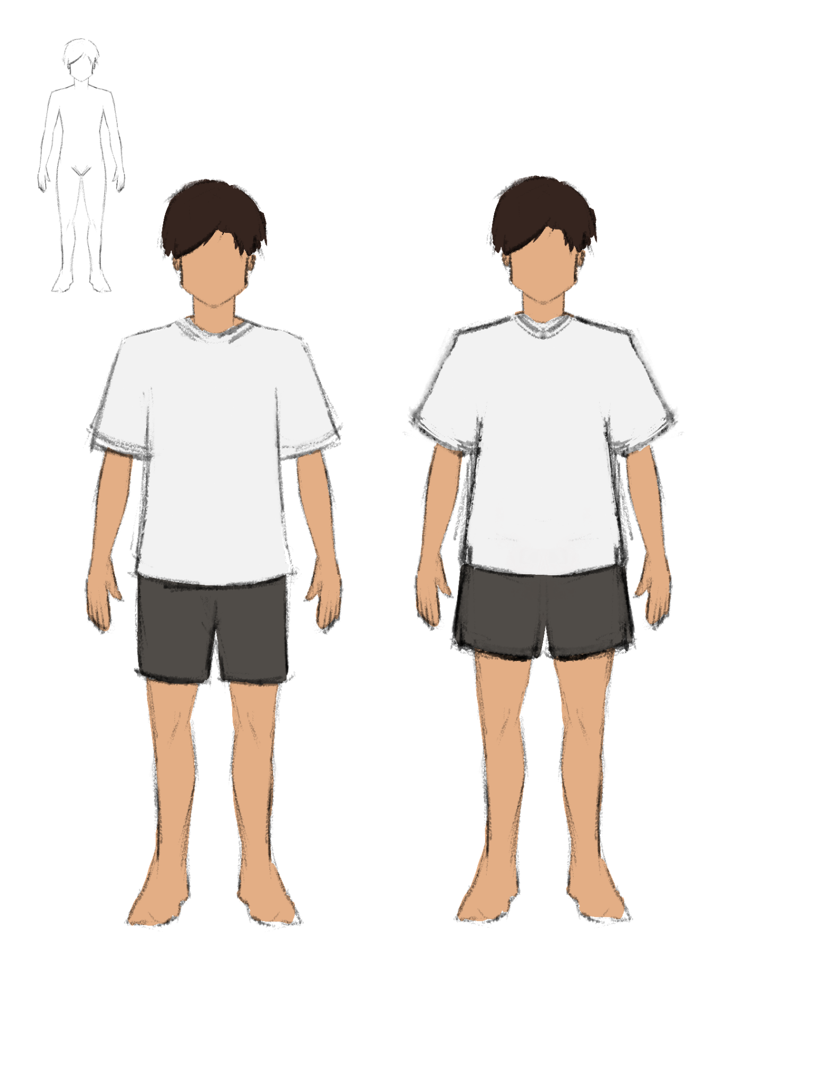

[Figure 1.1 Kian Di-Matibag Concept Art]
Environment:
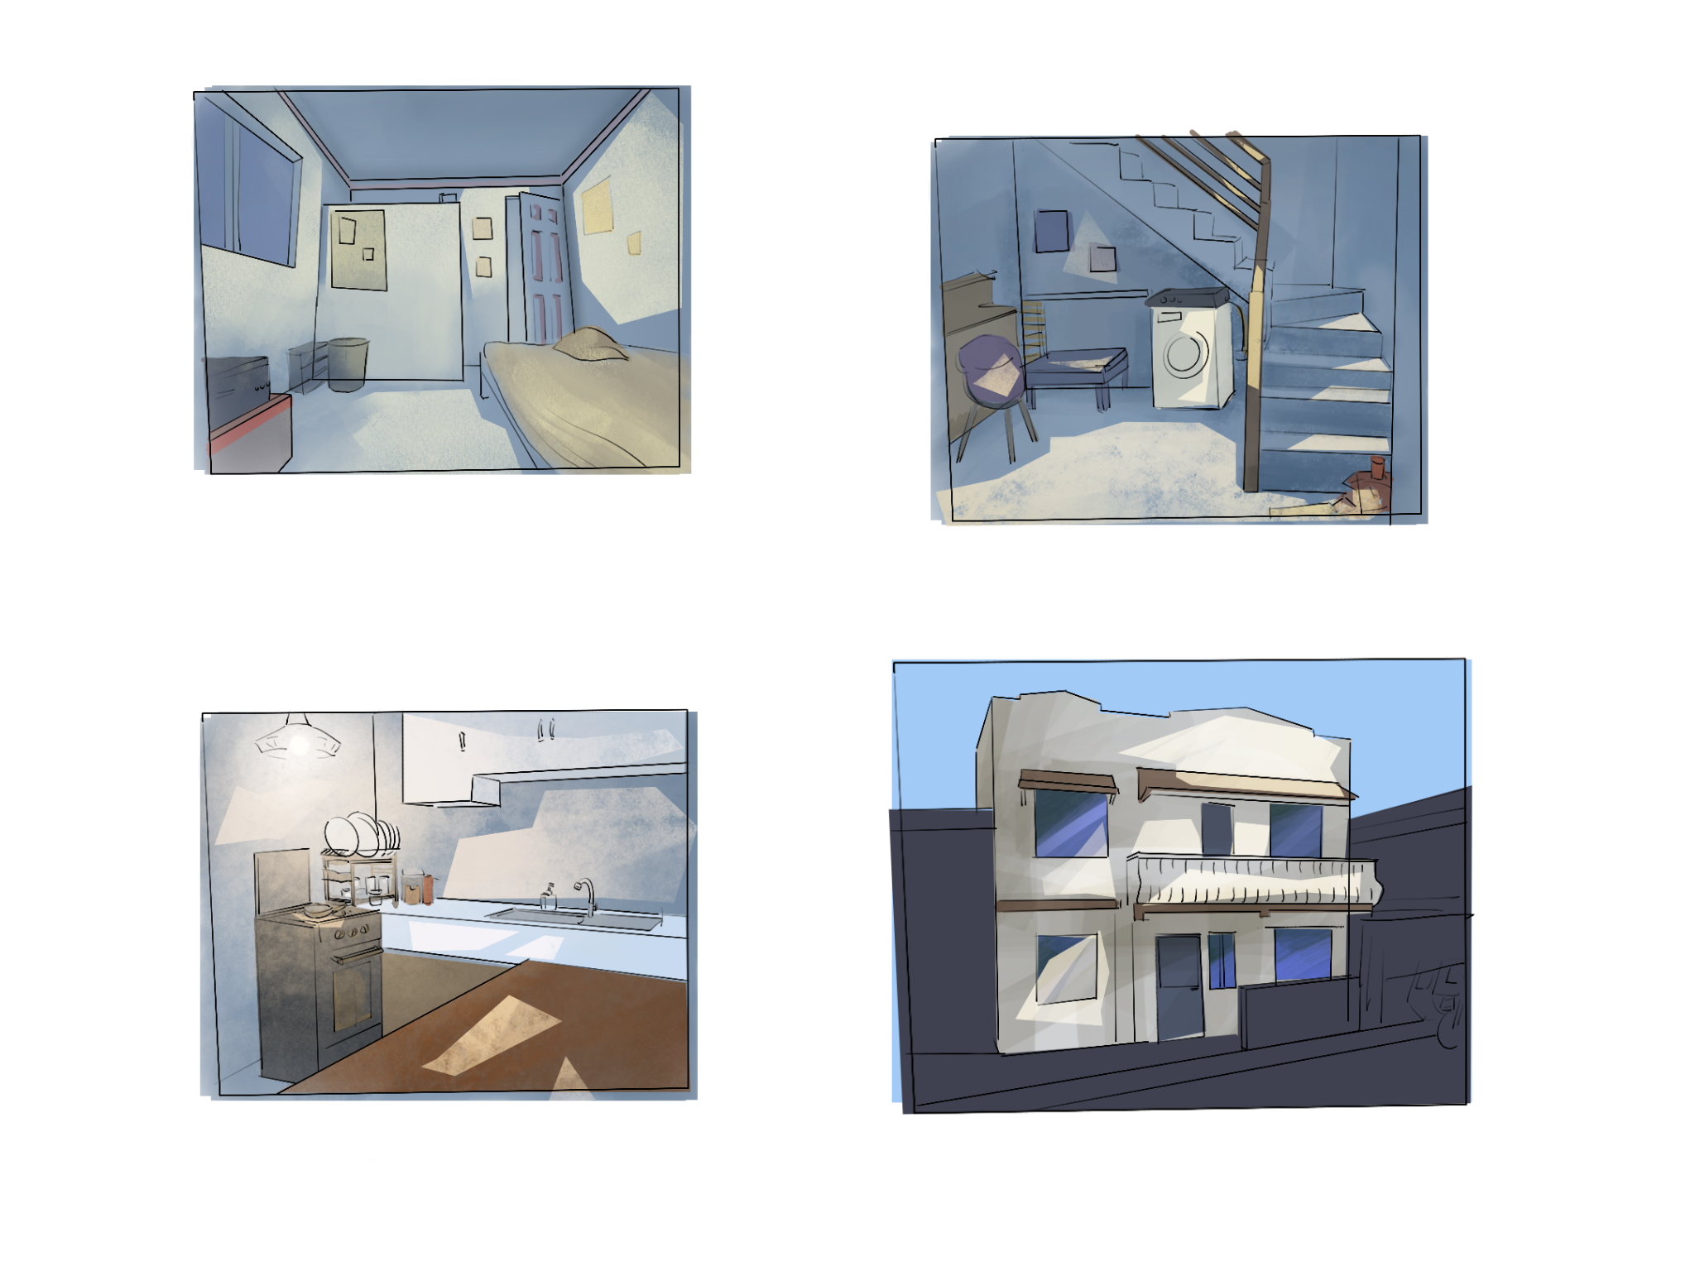

[Figure 1.2 House Concept Art]
CHAPTER IV

DISCUSSION OF RESULTS

This chapter outlines the progress of the project, highlighting the development process and its results. It includes discussion of the results of objectives, elaborating each objective and to significantly relate the project to the development. Additionally, this chapter discusses the results of production addressing each targeted goal. Furthermore, it discusses the effectiveness of the project pipeline, focusing on the improvements made by making the workflow effectively. Through examining the results and elaborating the objectives and discussing the production process, this chapter comes up with an overview of the project’s development in achieving the goals efficiently.

Discussion of Project Results

Objective 1
The objective to educate students about disaster risk management through simulated gameplay. The proponent developed a simulation game that focuses on giving important lessons when it comes to mitigation and survival during disasters, as per the project, a simulated typhoon disaster. To educated students, giving an experience through gameplay will ensure that they will learn and keep them from being bored from lectures. This approach leads to a fruitful understanding and an engaging experience for the players / students.

Objective 2
The objective to provide experience about preparing, responding, and restoring in a simulated typhoon disaster scenario. Players will be educated on the proper procedures to take while at the same time, brings out a rather familiar experience, only exaggerated to a degree for gameplay purposes. This experience will come out familiar or rather vague, differs from each player, with that, the proponent ensures that engagement and curiosity will play hand by hand through each gameplay from different players.

Objective 3
The objective to develop a 3D simulation game for teaching proper typhoon disaster preparation, response, and restoration. The proponents developed a game that will bring about a new experience through a gameplay but at the same time, making players feel somewhat already familiar with the setting and phenomenon unfolding within the game. The proponent’s goal for developing Listo is to spread awareness and teach players how to deal with the harsh reality of when a strong and destructive typhoon wreaks havoc. Developing a 3D game will add immersion and ambience, offering a more versatile game world where the player can fully move around without the restrictions of a 2D build.

Production Results

Pre-Production

Characters and Game Premise

Kian Di – Matibag

[Figure 2.1 Game Character]

Kian Di-Matibag is an average young adult male, studying in college, in home clothing. This design will add immersion to the simulation presented.

The Di – Matibag Residence

[Figure 2.2 Game Premise]

The premise of the game happens within the Di-Matibag Residence. All the episodes will take place inside and outside the house while most of the collectible items are inside the house.

Story

Kian Di-Matibag is a college student from BISCAST. School was cancelled due to the upcoming super typhoon (“Halina”). Kian grew excited, thinking about everything he can do for leisure while at home. While feeling carefree about the upcoming typhoon, Kian received a message from his mother who is worried about him. She told Kian about the possible dangers that the typhoon can cause. This made Kian worry and made him start to fear the situation he’s in, with only the tools scattered in their house and his phone with his mother’s constant messaging, Kian must face the typhoon alone while securing important items and especially, his own life.

Story Progression

The game will start with the first level, the Preparation. In this level, the player will accomplish tasks before the next level begins. This level introduces the player to the game setting and the introduction of the story where the premise slowly transitions to a gloomier atmosphere. The next level is the Response; this level will challenge the player with time attack tasks and the need to survive the rising flood. This level requires players to save as many items as possible to prevent Kian from accumulating trauma. The last level is the Restoration; this level will be the player’s breather and will be assigned peaceful tasks without time pressure. This level will serve as the game’s epilogue.

Production

Gameplay

[Figure 2.3 Gameplay Snap 1]

The player must finish tasks efficiently while surviving the challenges of each level, ensuring they remain prepared and resilient throughout the disaster.

Level Design

[Figure 2.4 Level Design Map]

The level design promotes a home atmosphere for the player. Having simple mapping and furniture/appliances placement creates a rather familiar feel for better navigation and movement.

Game Mechanics

- The player must collect necessary tools scattered around the map.
- The player must be efficient in solving puzzles or fixing something to be able to be ready for the next level.
- After reaching a certain goal, the level will start whether the player has finished the tasks in the previous level or not.
- The response level will have time attack tasks and must be completed.
- In the Response level, the player must also find a way to survive while finishing tasks.
- Surviving is the top priority but filling up the trauma bar will make you lose the game.
- The player’s health bar will be replaced with the “Trauma bar” that starts with 0 and increases with failed tasks or missed tasks. The bar will decrease slightly with each successful task.
- Surviving the Response level, the Restoration level will commence. In this level, the player will be tasked with peaceful tasks.
- The tasks will not have a time pressure.

Game Story / Gameplay Progression

Main Menu

[Figure 2.5 Main Menu]

The game will start in the main menu of the game. The main menu has buttons for interaction; The play button brings the player to the episode menu, the settings button opens the settings menu for in-game experience settings calibration, the credits button shows all the proponent names and their contributions / roles, and lastly, the quit button exits the player from the game.

Episode Menu

[Figure 2.6 Episodes Menu]

The episodes menu shows different episodes that the player can cycle from. It is a given that finishing an episode unlocks it, enabling a player to skip on some episodes. Players will be required to start on episode 1 if it’s their first time playing it.

Settings

[Figure 2.7 Settings]

The settings show variables that can be adjusted/ changed for better user experience. It includes music and SFX adjustable sliders, a drop-down list for game resolution, and a checkbox for a full-screen window. These settings will help players to adjust their experience to their liking.

Episode 1

[Figure 2.8 Episode 1]

Episode 1 tackles the “Preparation phase” where players are introduced to the game setting and the main character’s dilemma. In this level, players are required to collect necessary tools and secure important items inside the house.
Episode 2

[Figure 2.9 Episode 2]

Episode 2 tests the player’s quick decision making with a time-attack approach. Players are required to follow set of tasks quickly to save as much items as possible before the flood takes over the setting.

Episode 3

[Figure 2.10 Episode 3]

Episode 3 is the last episode; this introduces the player to another mechanic like restoration. Players will be able to take it easy while helping the main character clean up the house.

Items

Non - Interactable
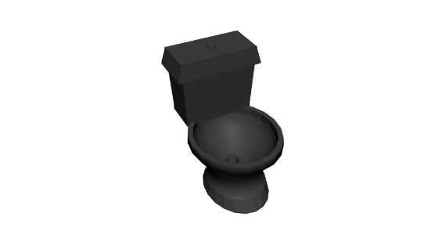

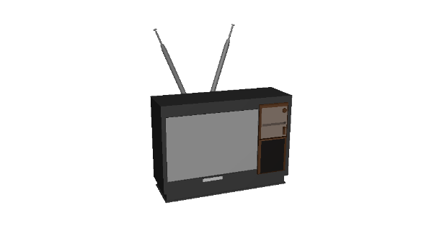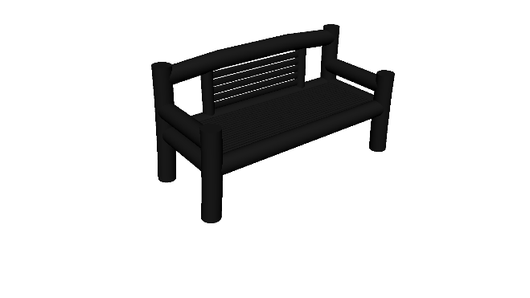

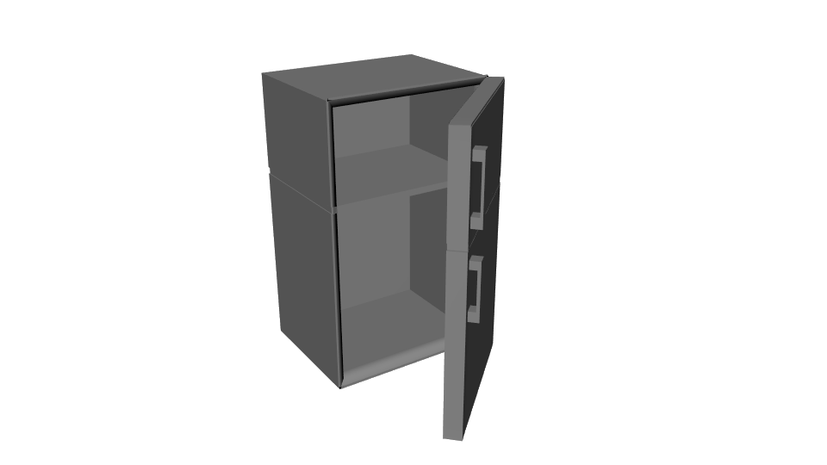

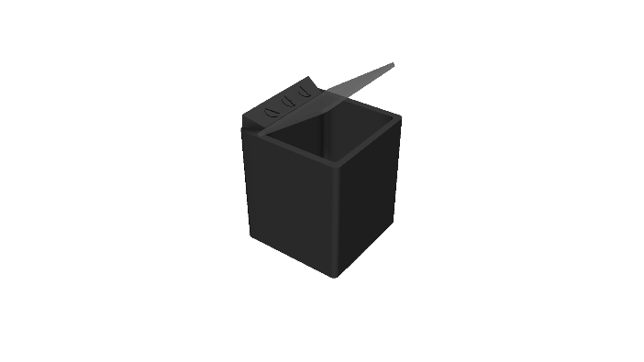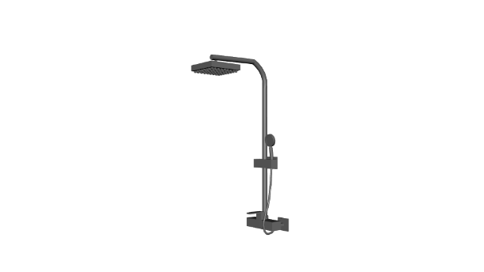

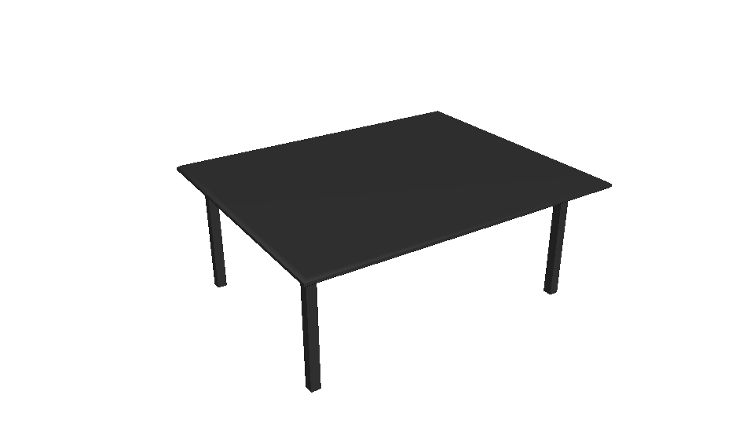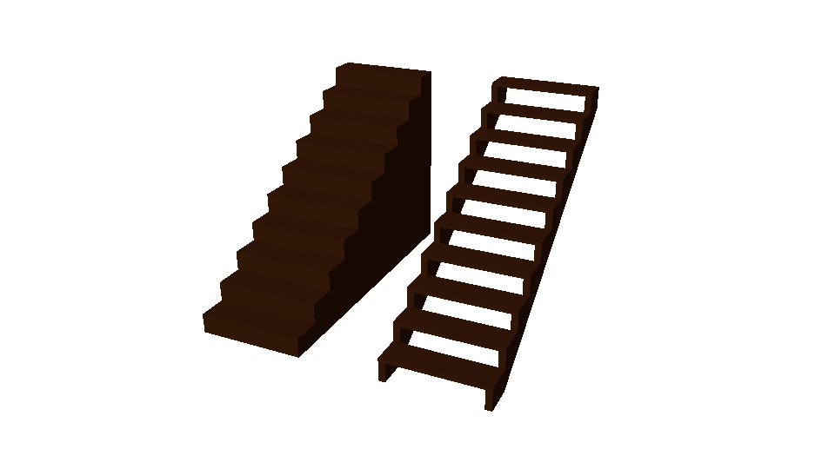

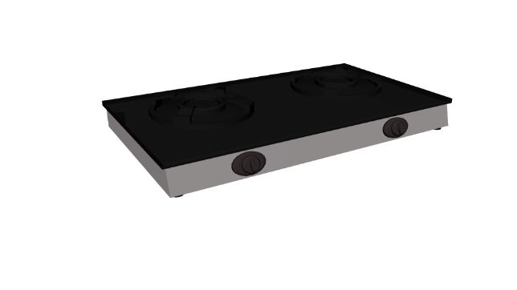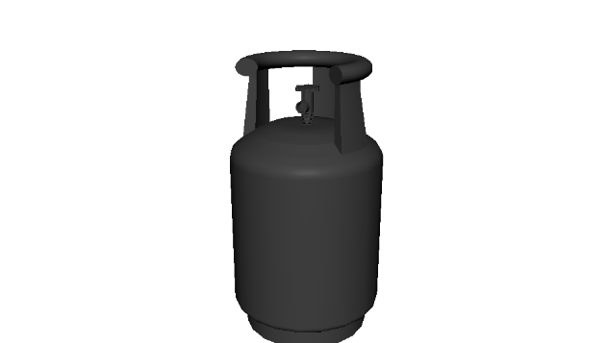

[Figure 2.11 Furniture and Appliances]

These are objects that are only lying around the game setting that won’t affect the gameplay. These are usually furniture and appliances.

Interactable

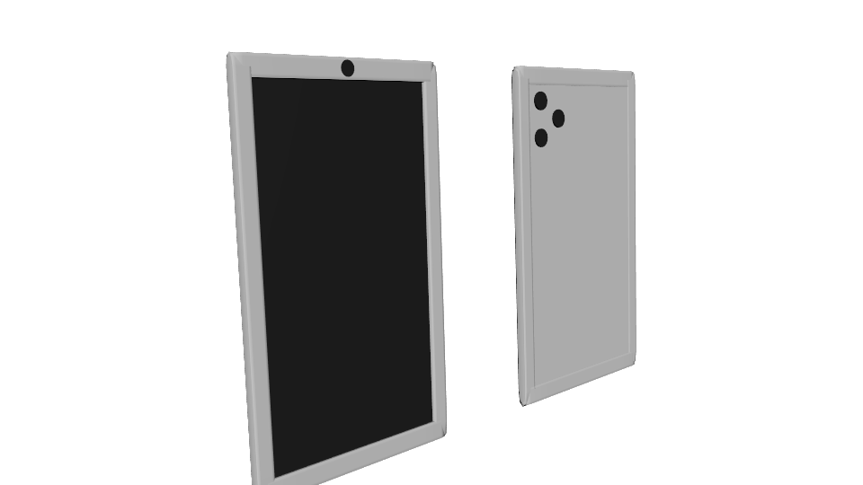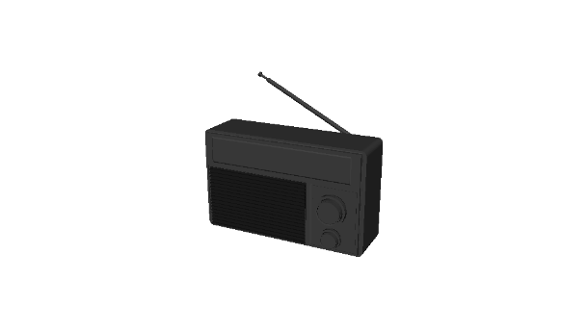
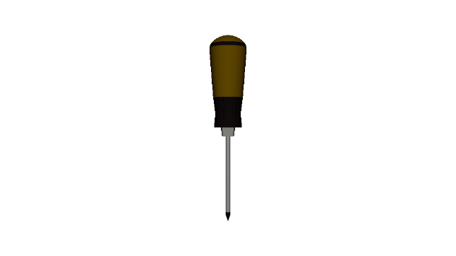
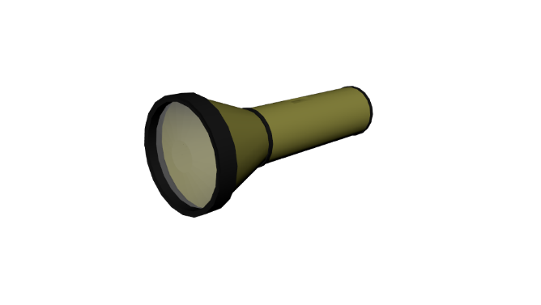
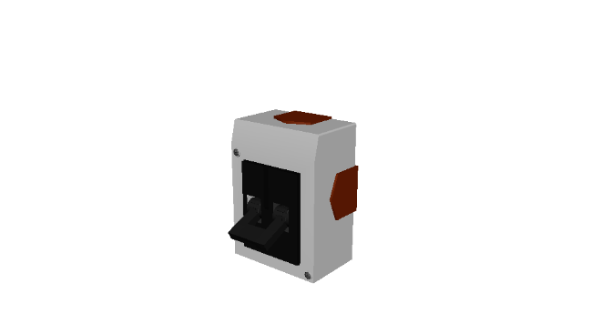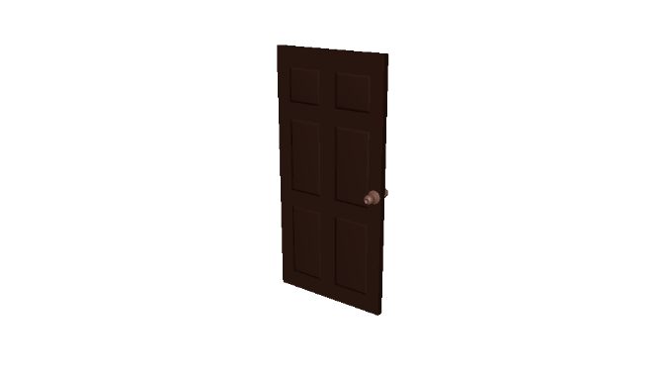

[Figure 2.12 Gadgets, Tools, and other interactable objects]

Players can collect necessary tools and items to aid their gameplay. These include a screwdriver, go-bag, a flashlight, candles, keys, and a lighter. These tools can help players depending on the tool’s usage.

Art Style

User Interface

[Figure 2.13 In-Game HUD]

The in-game HUD is created to be simple and efficient; this enables players to easily understand each icon or tutorial for players.

Progression and Challenges

The progression of the game will rely on the player's decisions of finishing tasks or not or successful or failure of tasks. The challenge is for the player to keep deciding for efficiency while taking the Trauma Bar in consideration.

Losing Mechanic

[Figure 2.14 Trauma Bar]

The player has a reverse health bar, named Trauma Bar. The bar will start with a value of 0 but will accumulate as the game goes by. It can accumulate faster when players fail to do tasks or miss some tasks.

Music and Sounds

[Figure 2.15 Music Editing]

The music is created through composition and foley. It is edited and enhanced in FL Studio for easy and accessible tools. Final adjustments and exporting are made in Audacity.

Post-Production Phase
Finalization and Production

[Figure 2.16 Game Snap 2]

Listo has been fully developed by the proponents. The game turned out great and is successful in completing all the project objectives.

Chapter V

CONCLUSION AND RECOMMENDATIONS

This chapter discusses the proponents’ conclusions as they develop a 3D simulation game for teaching typhoon disaster preparation, response, and restoration and recommendations for future developers who want to develop a similar simulation game.

CONCLUSION

The proponents concluded that developing a simulation game isn’t easy, especially in 3D. The project demanded a lot of factors that brought challenging problems throughout the development process.
A simulation game needs to have a particular feel that every player must share to make it an effective simulator game. One factor is the proper use of lightings; it depends on the game’s genre and game’s dimensions. Another is the game’s atmosphere; it also depends on the game’s genre but can also be affected by the game’s setting. Last example is, game mechanics, without a proper implementation of game mechanics, a game won’t be complete in general but in simulation games, a simulator goal will not be achieved. These factors are the major forces that keeps a simulation game in balance and effective in any genre.
Developing a simulation game can be both tricky and fearsome, developers must have an in-depth understanding of something before creating a simulation for it. If the result is not as familiar as the real experience, the simulation wasn’t effective.
Additionally, the development of this game was successful and came out more immersive than the proponents thought it would be since it held important life lessons that may help in case of a typhoon-related disasters.

RECOMMENDATIONS

The proponents of this project would like to recommend to the future developers:

Development Process:
- Finalize schedules for each part of the project to keep efficiency.
- Avoid mixing up codes, as much as possible, create separate scripts for different actions or non-similar codes.
- Have a backup for your assets and codes (Create a Gdrive folder or a local folder that holds all your project files)
- Rely on GitHub for better version control and easier updating for your project.

UI / UX Layouts:
- To make the text description bigger for the user to be able to read the texts easily.
- Be concise on text descriptions to avoid flooding the user’s screen.
- Make all the UI similar to your game’s mood and appeal.

Group Consultations:
- To always seek opinions and insights from people who has experienced the proposed simulation game firsthand.
- Always consult with your group adviser other instructors when it comes to technical issues.

Game Art and Design:
- To have consistency on both arts and scripts / codes compiling.
- Ensure proper character animations for better representation.

REFERENCES

Balanggoy, H. K. (2024). Implementation of disaster risk reduction and management. International Journal of Disaster Risk Management, 6(2), 119–131.
https://doi.org/10.18485/ijdrm.2024.6.2.8

Gov’t seeks P152-B for climate disaster risk reduction in 2021 | DENR. (2020, September 20).
https://denr.gov.ph/news-events/govt-seeks-p152-b-for-climate-disaster-risk-reduction-in-2021/

Abalos, E. (2023). PHL committed to achieving Sendai Disaster Risk Reduction Framework goals. Department of the Interior and Local Government.
https://dilg.gov.ph/news/ABALOS-PHL-COMMITTED-TO-ACHIEVING-SENDAI-DISASTER-RISK-REDUCTION-FRAMEWORK-GOALS/NC-2023-1117

Remulla, J. V. (2024, November 29). Remulla to LGUs: Integrate disaster risk reduction, climate change adaptation in local planning. Department of the Interior and Local Government.
https://dilg.gov.ph/news/Remulla-to-LGUs-Integrate-disaster-risk-reduction-climate-change-adaptation-in-local-planning/NC-2024-1129

Tizon, R. T., & Comighud, S. M. T. (n.d.-b). Implementation of the public schools’ Disaster Risk Reduction Management Program and level of capabilities to respond. UBT Knowledge Center.
https://knowledgecenter.ubt-uni.net/conference/2020/ed/1/

Gabriel, A. G., Santiago, P. N. M., & Casimiro, R. R. (2021). Mainstreaming disaster risk reduction and climate change adaptation in comprehensive development planning of the cities in Nueva Ecija in the Philippines. International Journal of Disaster Risk Science, 12(3), 367–380.
https://doi.org/10.1007/s13753-021-00351-9

Abenoja, S., Baog, I. W., Briz, A. C., Bustamante, H. M. M., Garcia, R., Mongado, R., & Ramos, A. J. B. (2023). The Implementation Level of Disaster Risk Reduction Management and Disaster Preparedness in Selected Schools in Davao de Oro. International Journal of Research Publications, 128(1).
https://doi.org/10.47119/ijrp1001281720235260

Cipres, M. C. C. (2023). Implementation of disaster risk reduction management of Visayas state university, Tolosa, province of Leyte-Philippines. Espergesia, 10(2), 65–78.
https://doi.org/10.18050/rev.espergesia.v10i2.2627

Disaster Management Reference Handbook - Philippines (March 2025) - Philippines. (2025, March 18). ReliefWeb. https://reliefweb.int/report/philippines/disaster-management-reference-handbook-philippines-march-2025

Pacific Disaster Center. (n.d.). National disaster preparedness baseline assessment (NDPBA) – Philippines. Pacific Disaster Center. Retrieved April 27, 2025,
https://www.pdc.org/wp-content/uploads/NDPBA_PHL_Final_Report.pdf

Tasantab, J. C., Amoako, C., & Inkoom, D. C. K. (2023). The efficacy of gamification in disaster risk education: Enhancing engagement and retention of disaster preparedness. Journal of Educational Technology, 28(2), 75-92.
https://doi.org/10.2196/64939

Bai, X., Hu, Y., & Zhuang, S. (2024). Gamification in disaster risk management education: A focused scoping review. International Journal of Disaster Risk Reduction, 52, 100928.
https://games.jmir.org/2024/1/e64939

Ismail, N. F., & Said, M. S. (2022). Teaching flood disaster response through digital simulation games: Enhancing comprehension of flood response tactics. Journal of Disaster Education, 19(3), 113-125.
https://www.sciencedirect.com/science/article/abs/pii/S1364815225001021

Andoh, A., Boateng, S., & Osei, P. (2021). Improving disaster preparedness through mobile disaster games: A focus on community literacy and awareness. International Journal of Mobile Learning and Organization, 15(4), 323-335. (Foreign)
https://www.researchgate.net/publication/352113558_An_android-based_mobile_educational_game_for_disaster_preparedness_an_input_to_risk_reduction_management

Mendez, J., & Stewart, M. (2020). The effect of serious games on teaching emergency response techniques in higher education. Journal of Emergency Management, 38(1), 44-55. (Foreign)
https://wmpllc.org/ojs/index.php/jem/article/view/2854

Rayos, F. A. S., Arcilla, J. A. T. B., Jacoba, C. G. R., & Del Mundo, E. F. (2024). HYDRA: A board game for disaster risk knowledge, awareness, and preparedness on hydrometeorological hazards. Asian Journal of Science Education.
https://discovery.researcher.life/article/hydra-a-board-game-for-disaster-risk-knowledge-awareness-and-preparedness-on-hydrometeorological-hazards/0741eb2c501234daa689dc8f5f5fef42

Liu, S., & Zhang, J. (2021). Enhancing disaster response training with AR and VR: Improving spatial awareness and decision-making skills. Journal of Virtual Education, 17(3), 123-135.
https://pmc.ncbi.nlm.nih.gov/articles/PMC11017811/

Wang, Y., & Li, K. (2020). Promoting teamwork and communication in disaster relief through online multiplayer games. Journal of Disaster Management Education, 21(4), 67-79. (Foreign)
https://www.researchgate.net/publication/337377479_Exploring_the_effects_of_a_serious_game-based_learning_package_for_disaster_prevention_education_The_case_of_Battle_of_Flooding_Protection

Tan, J., & Chia, H. (2022). Using educational games for teaching disaster risk reduction in secondary schools. Journal of Educational Research and Practice, 14(2), 115-126.
https://d1wqtxts1xzle7.cloudfront.net/117185329/EEC-1_2-libre.pdf?1722658919=&response-content-disposition=inline%3B+filename%3DDisaster_Risk_Reduction_for_Students_thr.pdf&Expires=1745772970&Signature=dLB-visFVUgYXUpSbpe9w66HKw6JTShkxKQwFVfb393ls2OCjkX-~pO3v56jT9ze-eov5d9ics~z6nCpKJbYmOmcDMFlACay33a6cSL5PuW69tSHwvD9FBEMhDlbvv9ZTSPrQN-PhCHg93wugUbKEPZ7LEBCZ0zl1XYIfQeC~CoVz2ZcaMWV7tKuz6Isu93CsWjONg8IZlRAhZq2v7tY2vOLsKXICnbClJ7JlsFUTfZfiM2PPcznSGzUPVQQsu84Wh~gJdFffdwvpmJvpPanWo4gEM3JZUzPw~5fA7TViAXcKc~tPHT0h9HGgk4mHpMHCSTxt0wMzv4AGIVgEu~5Tg__&Key-Pair-Id=APKAJLOHF5GGSLRBV4ZA

Catedrilla, G. M. B., Lerios, J. L., Sapin, S. B., Lanuang, M. C., & Buama, C. A. C. (2021). An android-based mobile educational game for disaster preparedness: An input to risk reduction management. Indonesian Journal of Electrical Engineering and Computer Science, 22(2), 936–943. (Foreign)
https://ijeecs.iaescore.com/index.php/IJEECS/article/view/23985

Dulawan, J. M. T., Imamura, Y., Konishi, T., Amaguchi, H., & Ohara, M. (2024). A systematic framework for assessing social vulnerability to flood for integrated flood risk management: A case study in Metro Manila, Philippines. International Journal of Disaster Risk Reduction, 112, 104778
https://www.sciencedirect.com/science/article/pii/S2212420924005405

Rubio, C. J., Yu, I. S., Kim, H. Y., & Jeong, S. M. (2020). Index-based flood risk assessment for Metro Manila. Water Supply, 20(3), 851-859.
https://www.researchgate.net/profile/Insang-Yu-2/publication/338787613_Index-based_flood_risk_assessment_for_Metro_Manila/links/64c310c70fae1319bfbc4445/Index-based-flood-risk-assessment-for-Metro-Manila.pdf

Gacu, J. G., Monjardin, C. E. F., Senoro, D. B., & Tan, F. J. (2022). Flood risk assessment using GIS-based analytical hierarchy process in the municipality of Odiongan, Romblon, Philippines. Applied Sciences, 12(19), 9456.
https://www.mdpi.com/2076-3417/12/19/9456

Besarra, I., Opdyke, A., Mendoza, J. E., Delmendo, P. A., Santiago, J., Evangelista, D. J., & Lagmay, A. M. F. A. (2025). The cost of flooding on housing under climate change in the Philippines: Examining projected damage at the local scale. Journal of Environmental Management, 380, 124966.
https://www.sciencedirect.com/science/article/pii/S0301479725009429

Tolentino, P. L. M., Williams, R. D., & Hurst, M. D. (2025). Natural Flood Risk Management in Tropical Southeast Asia: Prospects in the Biodiverse Archipelagic Nation of the Philippines. Wiley Interdisciplinary Reviews: Water, 12(1), e70000.
https://wires.onlinelibrary.wiley.com/doi/full/10.1002/wat2.70000

Hilario, D. G., Jara, S. C., Almagro, R. E., & Tapayan, V. M. (2024). The Assessment on the Flood Mitigation Strategies of the Local Government Unit of Santo Tomas, Davao del Norte: A Basis for Policy Formulation.
https://www.researchgate.net/profile/Ronald-Almagro-2/publication/377145767_The_Assessment_on_the_Flood_Mitigation_Strategies_of_the_Local_Government_Unit_of_Santo_Tomas_Davao_del_Norte_A_Basis_for_Policy_Formulation/links/6596acf16f6e450f19ca85c2/The-Assessment-on-the-Flood-Mitigation-Strategies-of-the-Local-Government-Unit-of-Santo-Tomas-Davao-del-Norte-A-Basis-for-Policy-Formulation.pdf

Gacu, J. G., Monjardin, C. E. F., de Jesus, K. L. M., & Senoro, D. B. (2023). GIS-based Risk assessment of structure attributes in flood zones of Odiongan, Romblon, Philippines. Buildings, 13(2), 506.
https://www.mdpi.com/2075-5309/13/2/506

Cabrera, J. S., & Lee, H. S. (2020). Flood risk assessment for Davao Oriental in the Philippines using geographic information system‐based multi‐criteria analysis and the maximum entropy model. Journal of Flood Risk Management, 13(2), e12607.
https://onlinelibrary.wiley.com/doi/full/10.1111/jfr3.12607

Acosta, L. A., Eugenio, E. A., Macandog, P. B. M., Magcale-Macandog, D. B., Lin, E. K. H., Abucay, E. R., ... & Primavera, M. G. (2016). Loss and damage from typhoon-induced floods and landslides in the Philippines: community perceptions on climate impacts and adaptation options. International Journal of Global Warming, 9(1), 33-65.
https://www.inderscienceonline.com/doi/abs/10.1504/IJGW.2016.074307

Sundo, M. B., Alfonso, C. D. Q., Zafra, R. G., Velasco, P. P., Aguirre, J. J. C., & Madlangbayan, M. S. (2019). Flood risk assessment of major river basins in the philippines. GEOMATE Journal, 17(64), 201-208.
https://geomatejournal.com/geomate/article/view/488

Abid, S. K., Chan, S. W., Sulaiman, N., Nazir, U., Ismail, F., Ahmad, M. F., & Tasmin, R. (2024). Theoretical framework development for flood vulnerable communities using geographic information system for disaster risk reduction: Mediating role of flood risk perception. Paper presented at IEEA 2024, February 21–23, 2024, Tokyo, Japan. ACM. https://doi.org/10.1145/3653912.3653920

Gunnarsson, M., & Barquet, K. (2025). Nature-based solutions in municipal stormwater management in Sweden: Costs, co-benefits, responsibilities and policies. SEI Report. Stockholm Environment Institute.
https://doi.org/10.51414/sei2025.002

Ong, A. K. S. (2023). Determination of factors affecting flood response effectiveness using artificial neural network: A case study in the Philippines. In Proceedings of the 2023 10th International Conference on Industrial Engineering and Applications (ICIEAEU '23) (pp. 328–332). Association for Computing Machinery.
https://doi.org/10.1145/3587889.3588218

Feng, X., Klingaman, N. P., & Hodges, K. I. (2021). Poleward migration of western North Pacific tropical cyclones related to changes in cyclone seasonality. Nature Communications, 12, 6210. https://doi.org/10.1038/s41467-021-26369-7

Ng, S. L. (2022). The role of risk perception, prior experience, and sociodemographic in disaster preparedness and emergency response toward typhoons in Hong Kong. Natural Hazards.
https://doi.org/10.1007/s11069-022-05703-21

de Veluz, M. R. D., Ong, A. K. S., Redi, A. A. N. P., Maaliw, R. R., Lagrazon, P. G., & Monetiro, C. N. (2025). Expanding integrated protection motivation theory and theory of planned behavior: The role of source of influence in flood and typhoon risk preparedness intentions in Quezon Province, Philippines. Climate Risk Management, 48, 100706. https://doi.org/10.1016/j.crm.2025.100706

Kurata, Y. B., Ong, A. K. S., Ang, R. Y. B., Angeles, J. K. F., Bornilla, B. D. C., & Fabia, J. L. P. (2023). Factors affecting flood disaster preparedness and mitigation in flood-prone areas in the Philippines: An integration of Protection Motivation Theory and Theory of Planned Behavior. Sustainability, 15(8), 6657.
https://doi.org/10.3390/su15086657

Calipusan-Elnar, M., & Abocejo, F. T. (2022). Typhoon and flooding disasters’ lived experiences of Loboc residents in Bohol, Philippines. International Journal of Social and Environmental Issues, 2(3), 298.
https://doi.org/10.47540/ijsei.v2i3.298

Gao, Z., Geddes, R. R., & Ma, T. (2020). Direct and indirect economic losses using typhoon-flood disaster analysis: An application to Guangdong Province, China. Sustainability, 12(21), 8980.
https://doi.org/10.3390/su12218980

Tan, F. J. (2021). Flooding and flood modeling in a typhoon belt environment: The case of the Philippines. In J. P. Tiefenbacher (Ed.), Climate Change in Asia and Africa: Examining the Biophysical and Social Consequences, and Society's Responses (pp. 1-16). IntechOpen. https://doi.org/10.5772/intechopen.98738

Reuters. (2024, November 26). ADB approves $500 million loan for Philippines' climate change efforts. Reuters.
https://www.reuters.com/sustainability/sustainable-finance-reporting/adb-approves-500-mln-loan-philippines-climate-change-efforts-2024-11-26/

Robielos, R. A. C., Lin, C. J., Senoro, D. B., & Ney, F. P. (2020). Development of vulnerability assessment framework for disaster risk reduction at three levels of geopolitical units in the Philippines. Sustainability, 12(21), 8815.
https://doi.org/10.3390/su12218815

Associated Press. (2024, October 15). UN urges Asia-Pacific countries to invest more in preventing damage from disasters. AP News.
https://apnews.com/article/8060c66a5a6ae4ea1636f32f49f60972

Dela Cruz, R. D., & Ormilla, R. C. G. (2022). Disaster risk reduction management implementation in the public elementary schools of the Department of Education, Philippines. International Journal of Disaster Risk Management, 4(2), 1–15.
https://doi.org/10.18485/ijdrm.2022.4.2.1

Isabela State University. (2020). Five-year campus-based disaster risk reduction and management (DRRM) plan 2020–2025.
https://isu.edu.ph/five-year-campus-based-disaster-risk-reduction-and-management-drrm-plan-2020-2025/

Abella, G. P. L., Lansigan, F. P., Tubay, J. M., & Carmona, A. R. A. (2020). Systems approach to disaster risk reduction in comprehensive land use planning of San Jose City, Nueva Ecija, Philippines. Journal in Urban and Regional Planning. https://fishkillevents.msi.upd.edu.ph/index.php/SURP/article/view/7908
Tayone, G. A., & Salic-Hairulla, M. (2024). Development of a contextualized digital game on typhoon preparedness for Grade 8 learners. Journal of Innovation, Advancement, and Methodology in STEM Education, 1(3).
https://so13.tci-thaijo.org/index.php/J_IAMSTEM/article/view/726

UNICEF Philippines. (2023). Digital solutions help typhoon-affected teachers in learning recovery: A story from Dinagat Islands. Retrieved from https://www.unicef.org/philippines/stories/digital-solutions-help-typhoon-affected-teachers-learning-recovery-story-dinagat-islands

Appendices

Appendix A: Sketch for the Character concept

This section is dedicated to showcasing the raw, early-stage design explorations for our game’s main character. This appendix features a hand-crafted sketch that will help in making the final polished figure.

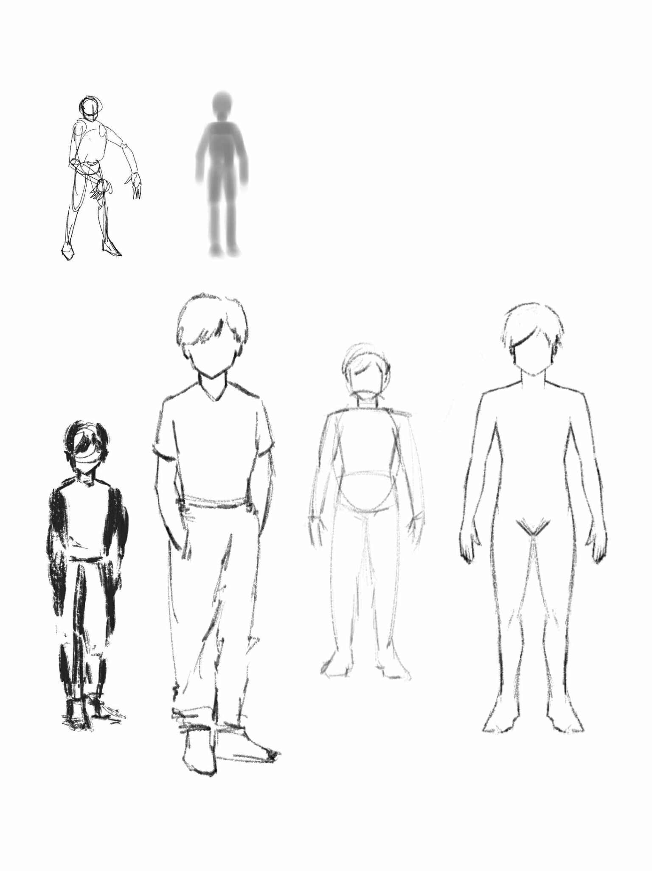

Appendix B: Sketch for Environment Concept Art

This section features hand-drawn sketches detailing proposed layouts, terrain configurations, and architectural elements that contribute to the overall ambience. The sketches portray the concept, reflecting the iterative process of transforming raw artistic ideas into a cohesive environmental vision. These initial drawings not only chart the evolution of our game’s world but also serve as a crucial reference for the design rationale and aesthetic choices implemented in later stages of development.

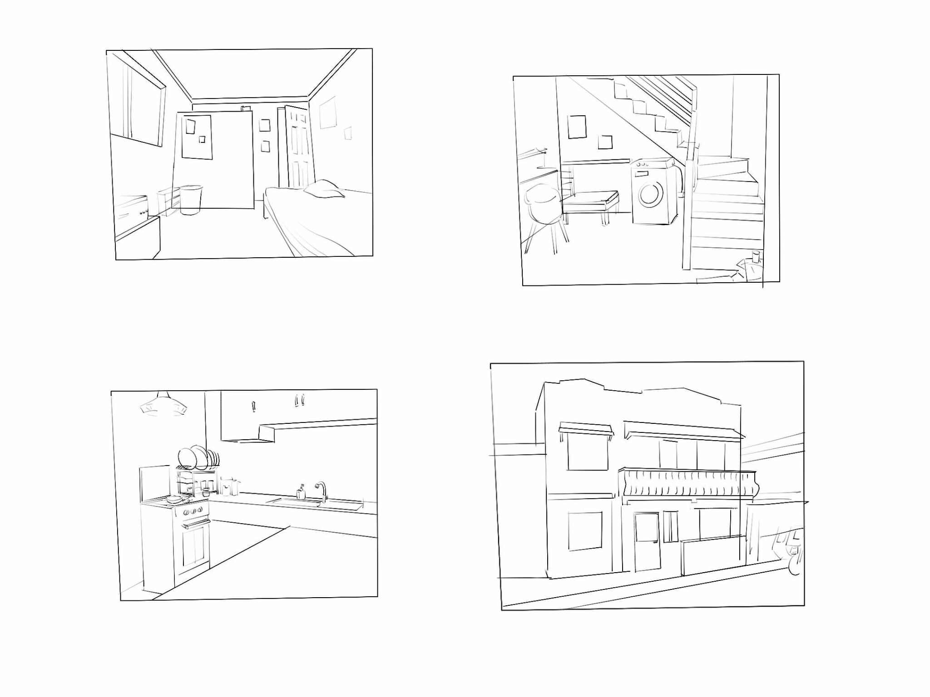

Appendix C: Flooding System

This section provides an insight on how the flood system works in the game. The proponents used URP for rendering quality and materials and used a simple plane with scripts to make it look like a real body of water. The proponents then proceeded to create an underwater visual for the player to create better immersion while submerged, this approach solved the game’s problem for “what would happen if the player were submerged?”. Of course, together with the visual, certain scripts that affect player behavior and stats are placed to promote a better simulation feel to the game.

Appendix C: Outside Environment

The environment around the game setting is a bunch of houses, representing a neighborhood where the game setting is placed in. These houses are not accessible and are beyond the players reach due to an invisible wall placed around the game setting, providing a boundary to keep the players engaged in the main goal of the game.

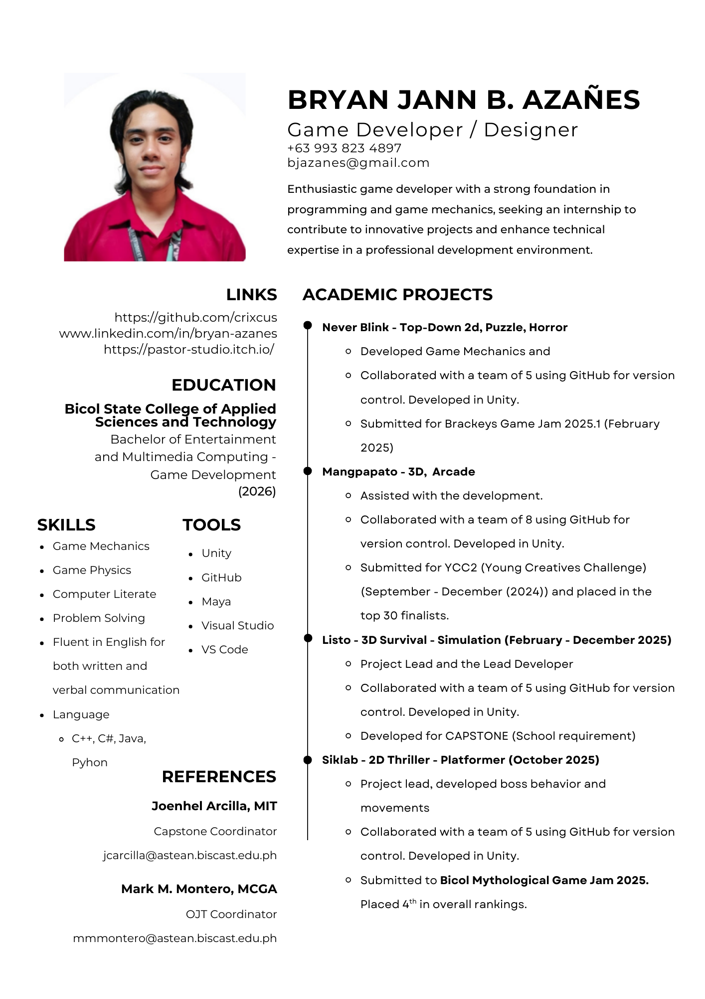
Curriculum Vitae
